# Medium Access Control (MAC)

## An access point uses the Point Coordination Function (PCF) of 802.11 to communicate with 10 laptops that are associated with it. After the contention free period has been completed, the laptops attempt to communicate with one another directly using the Distributed Coordination Function (DCF) of 802.1 – see figure 2 for a possible topology. Assume that at least a number of transmission attempts lead to collisions.

Describe the frames that are exchanged by the stations and the inter frame spaces that are involved in this exchange. Use diagrams to visualise the chronological exchange of the frames and the inter frame spaces.

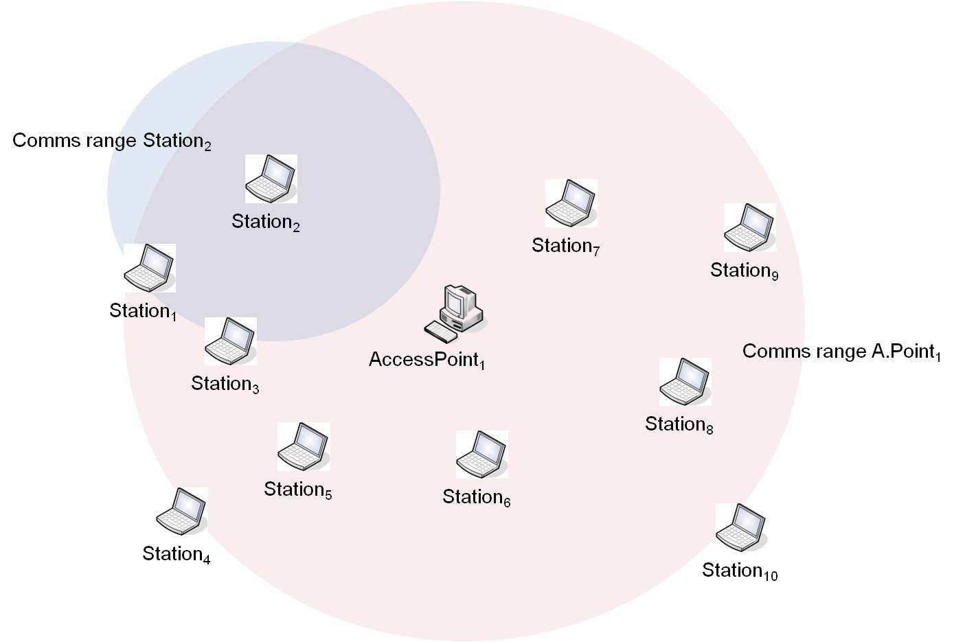

Figure 1: Possible 802.11 topology

## Three stations using 802.11 intent to transmit each 3 data frames to an access point. The times for the transmission for data frames and the Beacon are 190us, for RTS and Poll 180us, for CTS, ACK and CF-End 132us.

## i) Calculate the total time for the transmissions if the stations use DCF. Assume that the random numbers for backoff slots received by the stations are different for all the stations ie. that no collisions occur because of the same random numbers received by two or more stations. Indicate the random numbers that you are using for your calculations.

## ii) Calculate the total time for the transmissions if the stations use PCF. Assume that the access point uses only one contention free period for polling each station 3 times.



Exam Question:

* 1. IEEE 802.11 defines two methods for medium access control, the Distributed Coordination Function (DCF) and the Point Coordination Function (PCF).
     1. Describe the two methods, DCF and PCF, in your own words, and discuss the importance of interframe spaces.
     2. Explain the coordination of communication between an access point and 5 laptops when using DCF and when using PCF. Your explanation should be accompanied by diagrams that visualise the behaviour of the protocol and its limitations.

# Ethernet

## Assume that you have 2, 20 and 200 stations sharing an Ethernet segment. All stations intent to send frames at some stage during a 5 second window.

## Draw a diagram that visualizes the attempts by each station over times to acquire the medium to transmit and how the back-off times for the individual stations develop. Where times etc are not given, use your best judgement and state the assumptions that you are making.

## What is the effect of a scenario where stations send large frames e.g.1536 bytes compared against a scenario where stations send short frames e.g. 64 bytes?

## Switching

The Spanning Tree Algorithm is used to remove loops from local area networks that employ a set of bridges. Apply the algorithm to the following network and give the resulting spanning tree.

Short description of the algorithm:

1. Bridge with smallest ID is selected as root bridge
2. Mark port on each bridge with least-cost to root bridge as root port
3. Select designated bridge for each LAN that has root port with least-cost to root bridge – if two bridges have the same cost, select bridge with lowest ID
4. Mark root ports and designated ports as forwarding ports; other ports as blocking ports

A

C



D

B

K

F

H

J

G

I

B3

B1

B5

B2

B4

B7

B6



1

1

1

1

1

1

2

3

2

2

2

2

2

2

3

3

3

4

5

Figure 2: Network with bridges